Vlad Predovic

CS 352

Spring 2016

Unit 7.2 Activity: Attention Investment Activity

* Use your project group's prototype to “walk through” 1 to 3 (interesting!) steps a user would do to perform some task on your UI. For each step at which the user has a choice, list:
  1. How accurately users will be able to estimate the step to “cost" (in terms of their time, or other loss).
  2. How accurately users will be able to estimate the benefit from that step (in terms of saved time or other reward).
  3. How accurately users will be able to estimate the risk (probability) of losing the cost without getting the benefit after all.

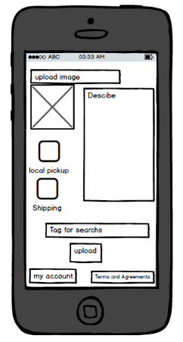Team 1 has the project lend it. I chose to walk through the step of uploading an item a user is willing to rent out.

1. The step to cost is estimated well for this section. This is because most of the work is displayed to the user in one screen, allowing them to take into account all the different steps that have to b taken in order to upload an item for rent.
2. The application assumes that once a user is uploading an item, they have a fairly good idea of what the incentive of renting an item, which is of course that you get paid. One possible improvement is adding a price option on this page to allow users to set a starting renting price. Another is to add a method of estimating the item’s popularity or succes in the area. This would promote the ability for users to estimate their benefit from uploading an item.
3. There is no good estimate currently involved in the step for losing the cost without getting the benefit. The benefit being having your item posted to the app and getting it rented by another user. This step would suggest uploading an item and no one renting it. As stated in part 2, a solution would be adding a method of estimating the item’s popularity.